**Information**

|  |  |  |
| --- | --- | --- |
| **CRIM ID** | **Title** | **Workstream** |
| C0446 | Create equipment object once CO is delivered – v0.1 | Service Management & COM |

**Revision History**

|  |  |  |  |
| --- | --- | --- | --- |
| **Revision** | **Date** | **By** | **Remarks** |
| 0.1 | 20/01/2021 | Erika Sukevic & Linzi Evans | Base spec |
| 1.0 | 05/03/2021 | Erika Sukevic | Updates |
| 1.1 | 28/05/2021 | Erika Sukevic | Subscription logic |
|  |  |  |  |

# CRIM Narrative

We need an event which will create equipment objects based on the information on the customer order.

Equipment objects are split by two types:

* Serial Object
* Functional Object

The event should only create objects for the parts which are marked as Serviceable on the site 2013.

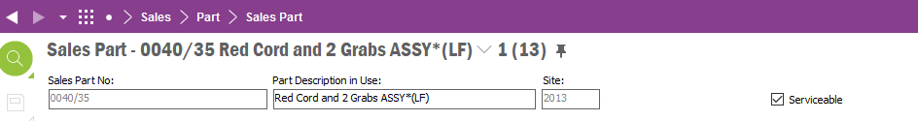

### Custom field to hold Object ID

We need a custom column on the Customer Order line to hold the Object ID against which all equipment objects will be created. This field should be LOV from functional object screen holding Object IDs and Description for objects, but it needs to have ability to enter Object ID without using LOV.

### Event Trigger

We need a trigger which would activate automation of objects creation. The proposed solution is to trigger the event using custom RMB called “Load parts to object”. This RMB should only be enabled when Customer Order status = Delivered or Closed/Invoiced and Object ID CF is populated.

### Data mapping and object creation

The following information needs to be taken from the customer order and associated to it screens to populate equipment object:

1. Part No
2. Installation Date
3. Serial No (if applicable)
4. Service Warranty
5. Equipment Quantity
6. Belongs to Object – taken from new CF on customer order line
7. Lot Batch No – new CF

Note that if the part is serialised then each part needs to be created as separate serial object. If part is not serialised, then same parts on the same delivery line from the same customer order can be merged in to one functional object with defined quantity.

If the part is serialised:

Below screenshots show where data is coming from.

No 2 – pick date where transaction description is “Delivered on customer order…”

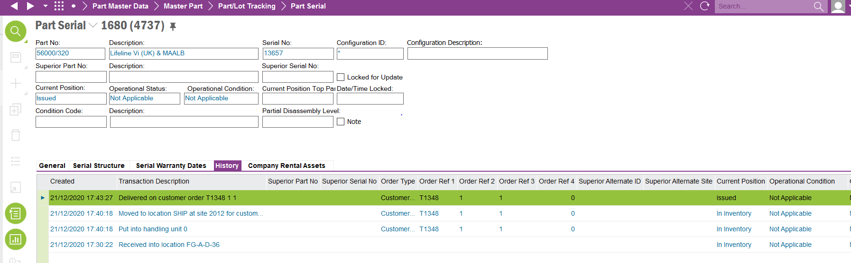

2

3

1

To determine the service warranty, check what warranty ID the part has. Then check what is the value this warranty represents. Please note that Warranty in customer orders world can be set to years (as example below) when in services world it is in months. The event needs to translate years to months eg 2 years = 24 months.

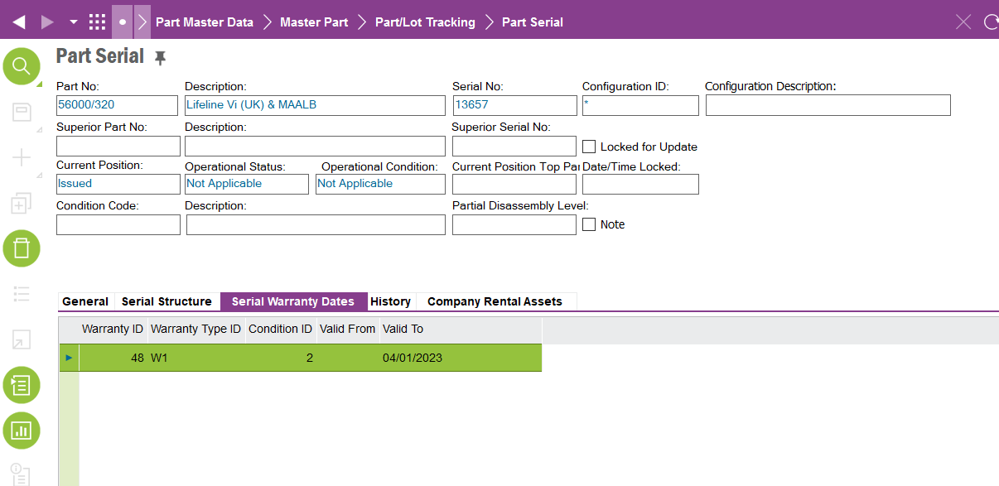

4

If the part is not serialised:

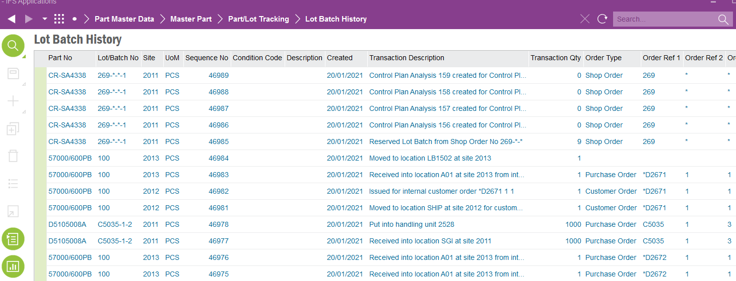

7

1

5

2

To access the warranty information, do RMB on the line select Order Line Details > Customer Warranty > View. The same data transformation on the warranty from years to months should apply as per serial object.

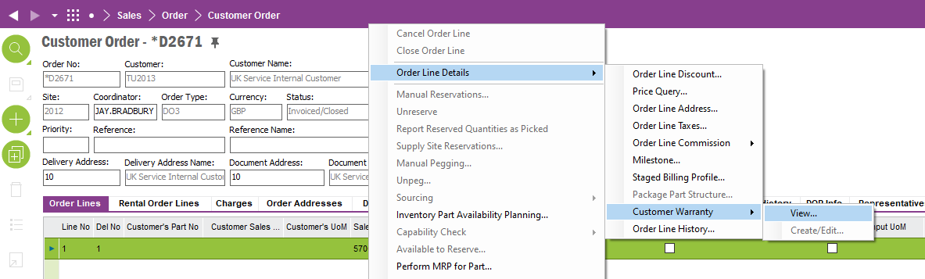

Below screenshot shows where data needs to be inputted.

We also need a new custom field to hold the Lot Batch No. This needs to be a free text field and located next to Serial No field.

Please note that the Functional Object screen is used for non-serialised parts. Serial Object screen is used for serial parts.

7

6

5

4

3

2

1

### Creation of serialised object

All the steps described in this section need to be automated by the event. If the part on the customer order has the serial number against it, we need to create a serial object. To do this, find the serialised part from the customer order on the Serial Maintenance Aware screen. Do RMB on the part which matches criteria select Make Maintenance Aware.

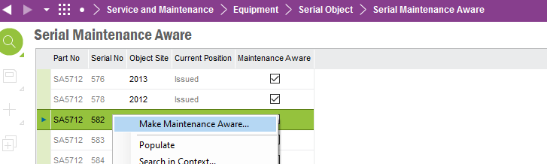

On the pop-up box always populate Site field with value “2013”. Keep Object ID field blank – this will allow system to generate Object ID automatically. Click OK.

On the pop-up box always select “No”.

Then go to Report In Work Order screen and populate screen on any record. This will enable RMB “Part Serial Equipment Structure” functionality. Note: this functionality is not available on the separate screen, so we need to access it this way.

On the pop up box enter Object ID from the custom field on the Customer Order line. Enter Part No and Serial of the part from the customer order. Click OK.

This creates the serial object in the structure.

### Functional Object Creation

If the part on the customer order doesn’t have the serial number, then the automation should create a new functional object where:

* Belongs to Object field = selected object ID on the customer order line
* Object level = 900_FUNCTIONAL_EQUIPMENT
* Object ID = Part No + CO ID + Delivery No
* Object Description = Part Description
* Site = 2013

Object Id consist of the fields highlighted below:

### Subscription creation

We need an additional logic to connect functional object to the multiple serial objects if the part on the functional object is a subscription.

To identify the subscription part, find a non-inventory sales part marked as serviceable.

This non-inventory sales part should be created the same way as not serialised sales part – using functional object functionality and populating all fields as per 1.1.5.

This subscription always comes with the serialised part (SmartHub) on the same customer order and we need the ability to connect these two records together. Once the event created serial objects for smart hubs and functional object for subscription the event needs to connect these records via Connected Object functionality. To identify which subscription part is connected to which serial part use Complimentary part set up screen. The parent is the smarthub and the complimentary part is the subscription.

On each serial object the event should create the line under Connected objects tab where:

* Connected Object Site = 2013
* Connected Object ID = Object ID of the subscription functional object
* Connection Type = SUBS

# Design Q&A

# BA/Developer Notes/ Related CRIM

# Technical Proposal

*\*\*\*\* Guidance Notes – Remove prior to submission \*\*\*\**

***********************************************

# Technical Solution

## Technical Process

***********************************************

## Report Components

********************************************

## Known Dependencies

*\*\*\*\* Guidance Notes – Remove prior to submission \*\*\*\**

***********************************************

# Deployment Instructions

*\*\*\*\* Guidance Notes – Remove prior to submission \*\*\*\**

***********************************************

# Developer Test Proposal

*\*\*\*\* Guidance Notes – Remove prior to submission \*\*\*\**

* *Tests recommended by the developer to be included in UAT*

*e.g.*

| **Test ID** | **Recommended Test** |
| --- | --- |
| 1 | Test the boundaries of all parameters |
| 2 |  |
| 3 |  |
| 4 |  |
| 5 |  |
| 6 |  |
| 7 |  |

***********************************************

# User Acceptance Tests

***********************************************

***********************************************

# Feedback Comments in Mails for C446 during development

* Same logic as per C0177 is in placed as requested - if the user runs event on the same object as before a notification will popup that object already exist; and if the event is executed on the same CO line but input different object it moves previously created objects from one structure to another (If object is changed then we need to update the ‘Belongs to field’ and move the object to correct place in equipment navigator)
* Check for serviceable on site 2013 and check warranty on site 2012, can we make both checks on the same site to be consistent. Use 2012 for the checks but when it creates the object it is always in 2013. The check is just to check the serviceable flag.
* When equipment is created, do not need to populate Location ID field.

* Event created 5 serial objects and subscription part should connect to all 5.

# Delivery Notes

* Package - EA_SERVICES
* Permission Sets – IFS_ALL
* Custom Menu – Load Parts to Objects.

Note: - If the Menu is not available on the Customer Order Window, check if the event is approved and published and then reload configurations on the Customer Order Window.

* Custom Fields shown below (In EA_SERVICES) should be approved, published, and synced.

* Following (In EA_SERVICES) custom events and custom event actions need to be approved, published, and synced.

* DB Util Package - C_EA_Customization_Util_API.

The following methods need to exist in the API

1. Create_Equipment_Object__
2. Create_Functional_Object_
3. Create_Serial_Object__